Come try Craft Group!
Do you want to:
- Meet new friends in the Orana community
- Build up your community hours
- Learn new skills
- Support the Spring Fair and Seasonal Community Markets?
The Orana Craft Group meets in the Kurrajong Room from 10 to 1 on most weekends, and welcomes new members of the Orana family.

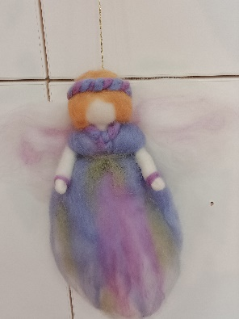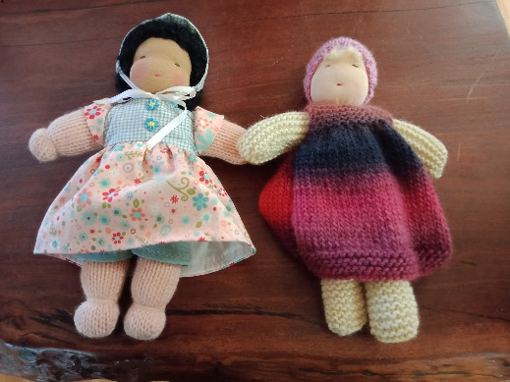

No experience or equipment needed!
Visit our page on the school website for the calendar of crafts in Term 2 2021:
https://www.oranaschool.com/community/craft-group.html
or
email us at craftgroup@oranaschool.com to join the mailing list and find out what beautiful craft we’ll be doing this week!

